CS 255 System Design Document Template

UML Diagrams

UML Use Case Diagram
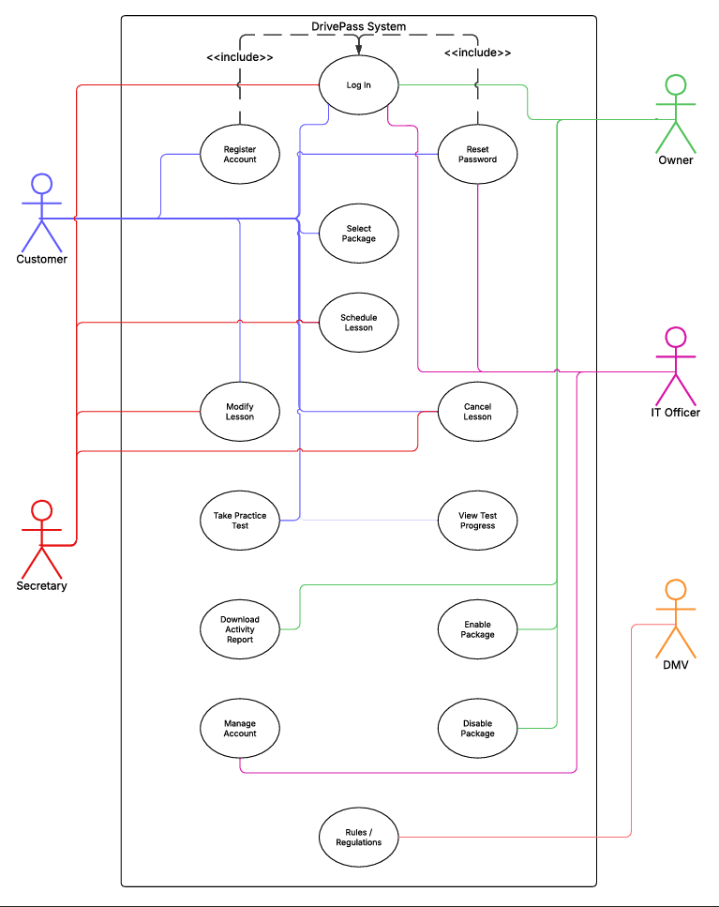

UML Activity Diagrams
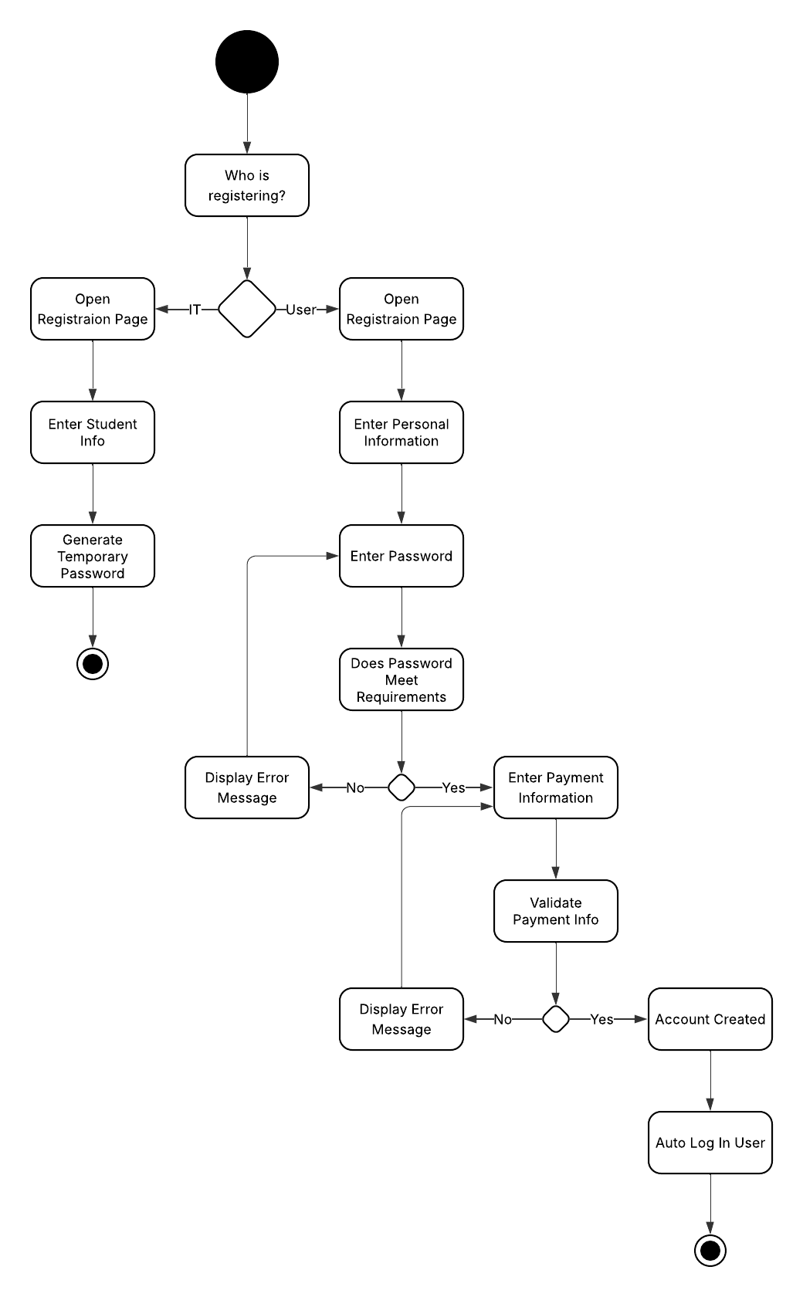

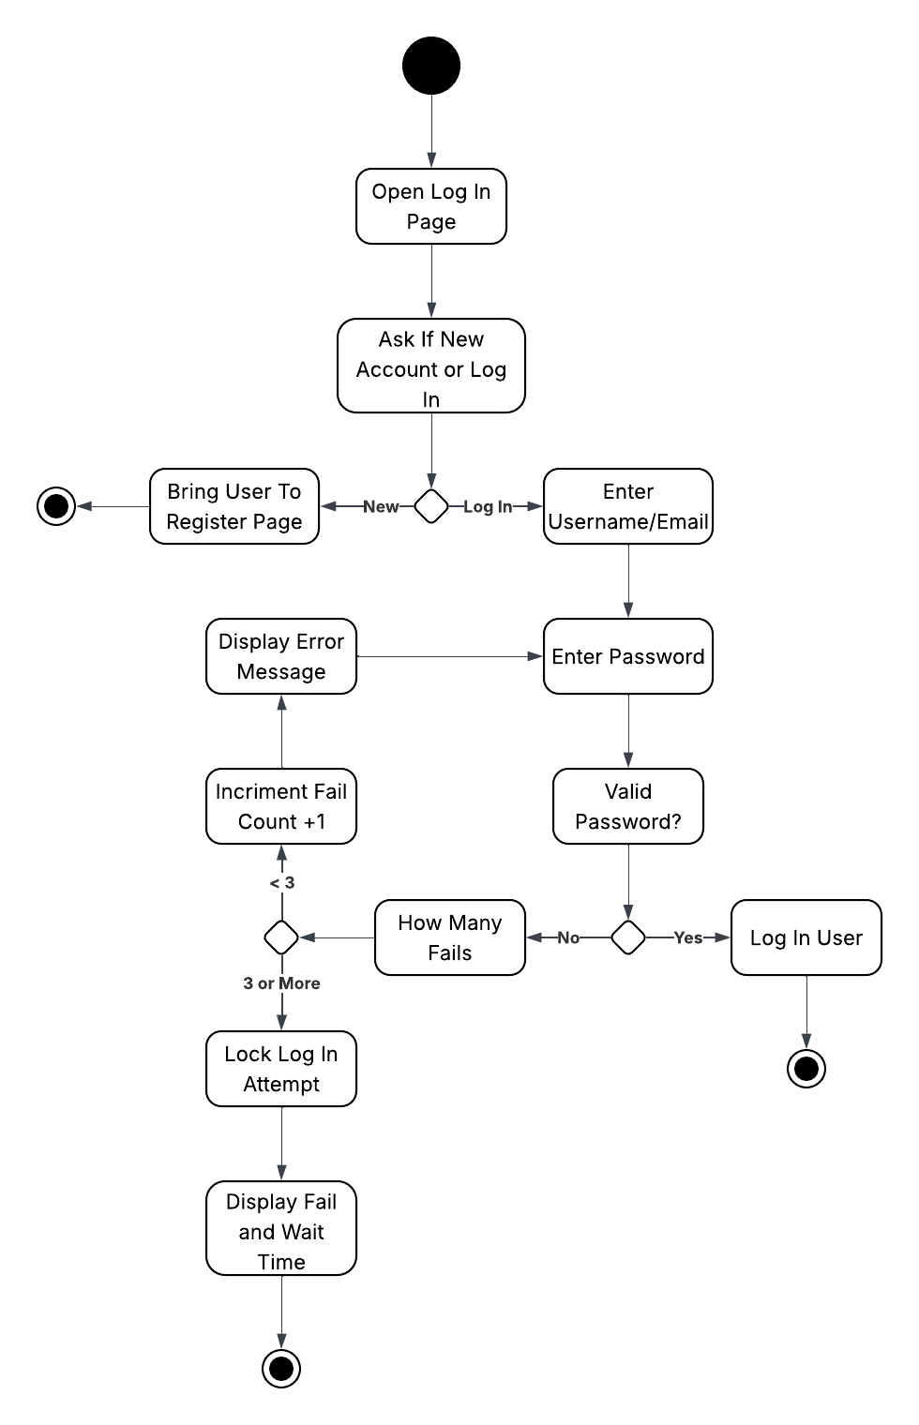

UML Sequence Diagram
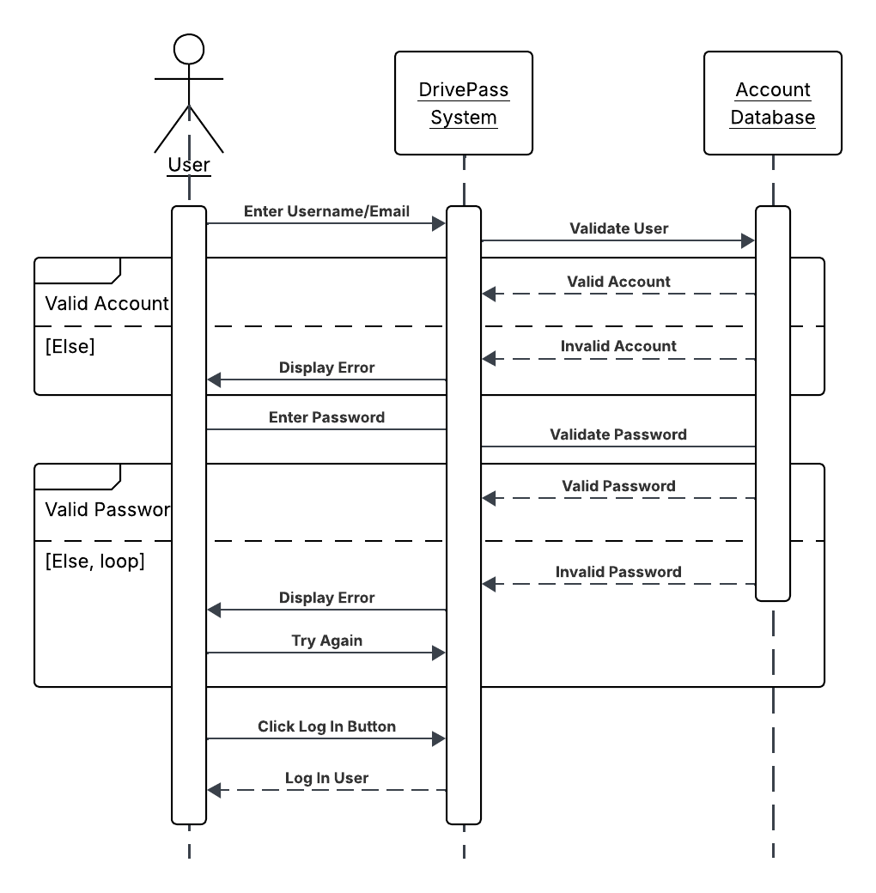

UML Class Diagram
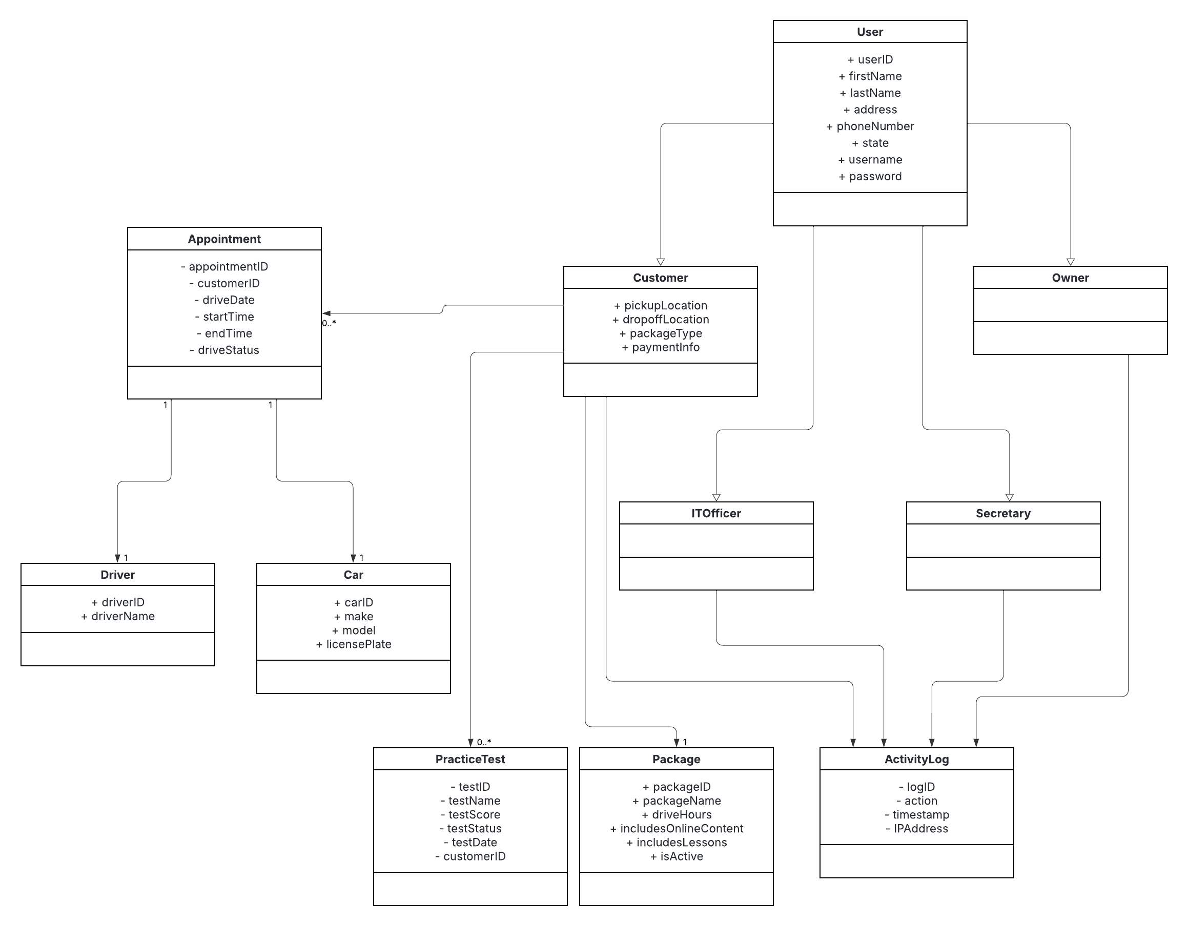

Technical Requirements
The DriverPass system is a cloud-based application, requiring no specific hardware requirements from the clients outside of a web browser and internet connection. From the server end the system will require a cloud hosting service. This will handle our data storage and backups. It will also provide up-time monitoring and server maintenance so our team can focus on running and advancing the business. A database will be needed to store all pertinent information for all users as well as appointments, packages, tests and results, activity logs, and more. To secure data transfers we will need SSL encryption. Finally, we will need an external API to receive all updates from the DMV so we can provide our customers with the most accurate information possible.

